TAREA 7

Salguero Hernández Juan Pablo



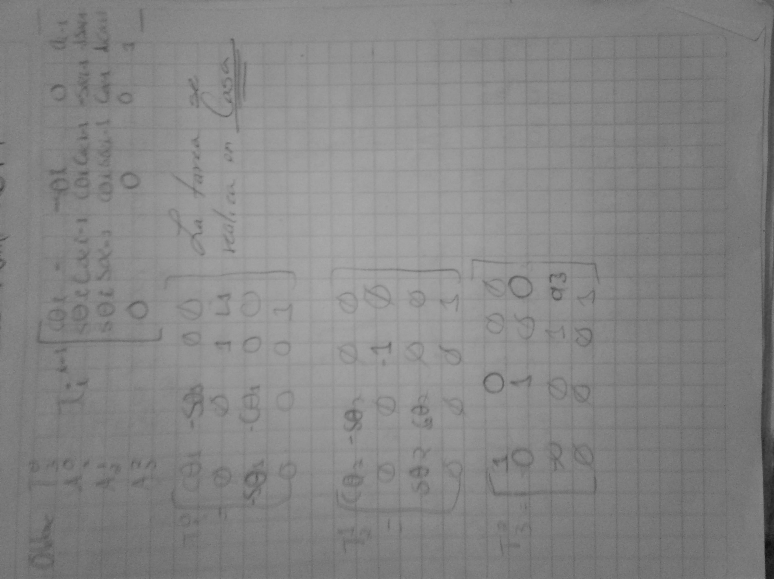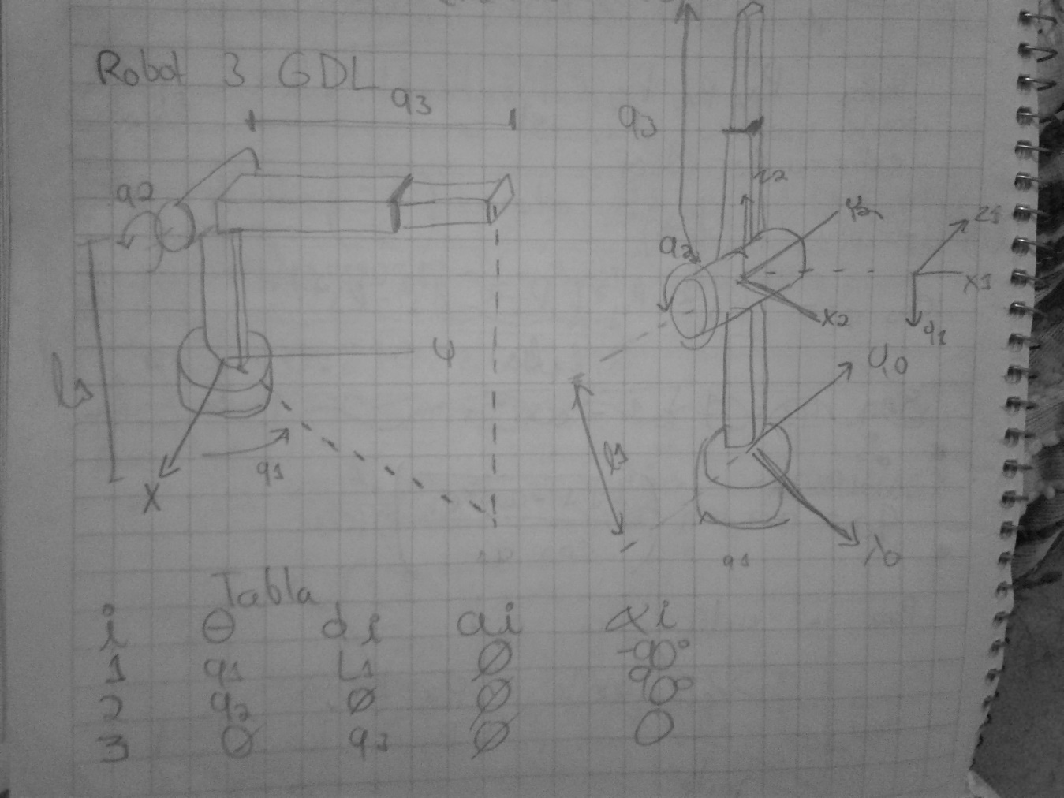

|  |  |  |  |  |
| --- | --- | --- | --- | --- |
| Articulación | $$a_{i-1}$$ | $$∝_{i-1}$$ | $$di$$ | $$θi$$ |
| 1 | 0 | -90 | L1 | $$q1$$ |
| 2 | 0 | 90 | 0 | $$q2$$ |
| 3 | 0 | 0 | q3 | $$0$$ |

**Calculo de la matriz Homogénea**

$$T_{i}^{i-1}\left[\begin{matrix}Cθi & \begin{matrix}-Sθi & 0 & { a}_{i-1}\end{matrix} \\ \begin{matrix}SθiC∝_{i-1} \\ SθiS∝_{i-1} \\ 0\end{matrix} & \begin{matrix}CθiC∝_{i-1} & -S∝_{i-1} & -diS∝_{i-1} \\ CθiS∝_{i-1} & C∝_{i-1} & diC∝_{i-1} \\ 0 & 0 & 1\end{matrix}\end{matrix}\right]$$

$$T_{1}^{0}\left[\begin{matrix}Cq1 & \begin{matrix}-Sq1 & 0 & 0\end{matrix} \\ \begin{matrix}0 \\ -Sq1 \\ 0\end{matrix} & \begin{matrix}0 & 1 & L1 \\ -Cq1 & 0 & 0 \\ 0 & 0 & 1\end{matrix}\end{matrix}\right]$$

$$T_{2}^{1}\left[\begin{matrix}Cq2 & \begin{matrix}-Sq2 & 0 & 0\end{matrix} \\ \begin{matrix}0 \\ Sq2 \\ 0\end{matrix} & \begin{matrix}0 & -1 & 0 \\ Cq2 & 0 & 0 \\ 0 & 0 & 1\end{matrix}\end{matrix}\right]$$

$$T_{3}^{2}\left[\begin{matrix}1 & \begin{matrix}0 & 0 & 0\end{matrix} \\ \begin{matrix}0 \\ 0 \\ 0\end{matrix} & \begin{matrix}1 & 0 & 0 \\ 0 & 1 & q3 \\ 0 & 0 & 1\end{matrix}\end{matrix}\right]$$

$$T_{3}^{0}\left[\begin{matrix}Cq1Cq2 & \begin{matrix}-Cq2Sq1 & Sq2 & L2Sq2\end{matrix} \\ \begin{matrix}Sq1 \\ Cq1Sq2 \\ 0\end{matrix} & \begin{matrix}Cq1 & 0 & 0 \\ -Sq1Sq2 & Cq2 & L1q3 \\ 0 & 0 & 1\end{matrix}\end{matrix}\right]$$